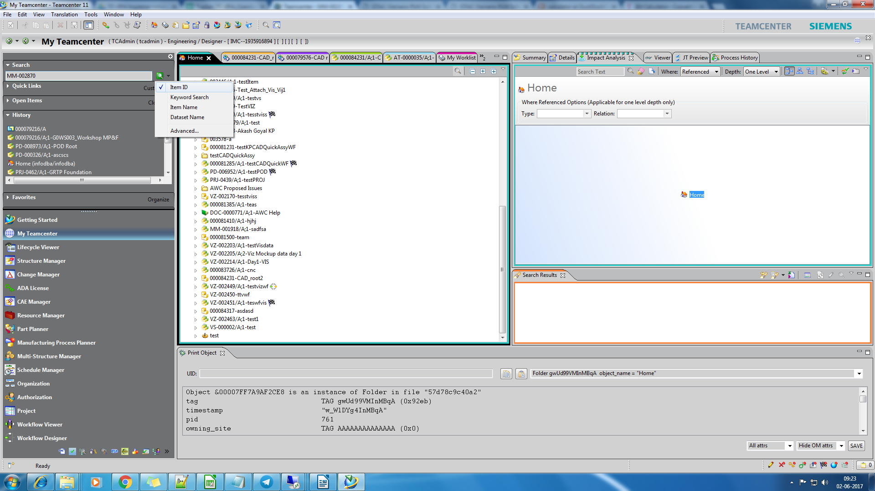
1) Search for the item id you want to upload

2) the item id appears as below

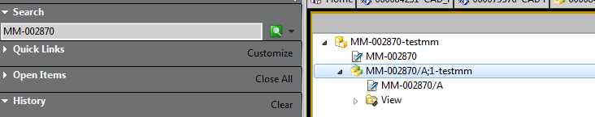

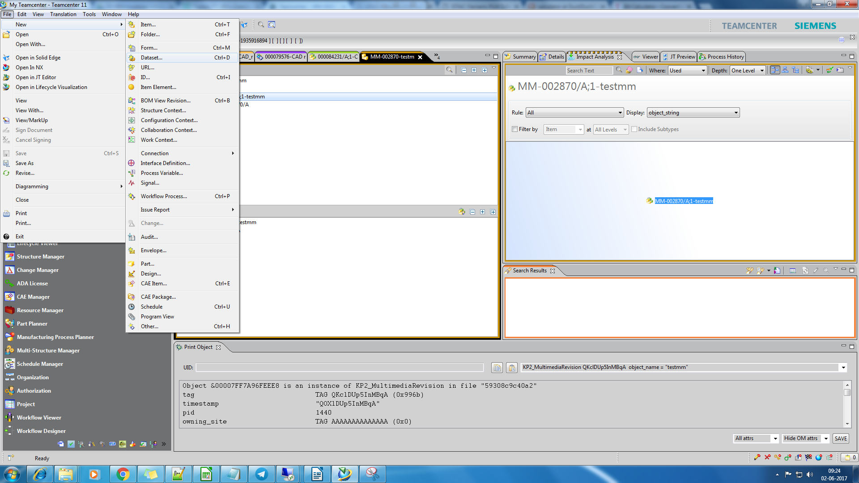
Select the Item revision and click file-> dataset....

4) A dialog box will open , asking to provide dataset , click more and scroll down to select Movie(if you wnat to upload movie dataset)

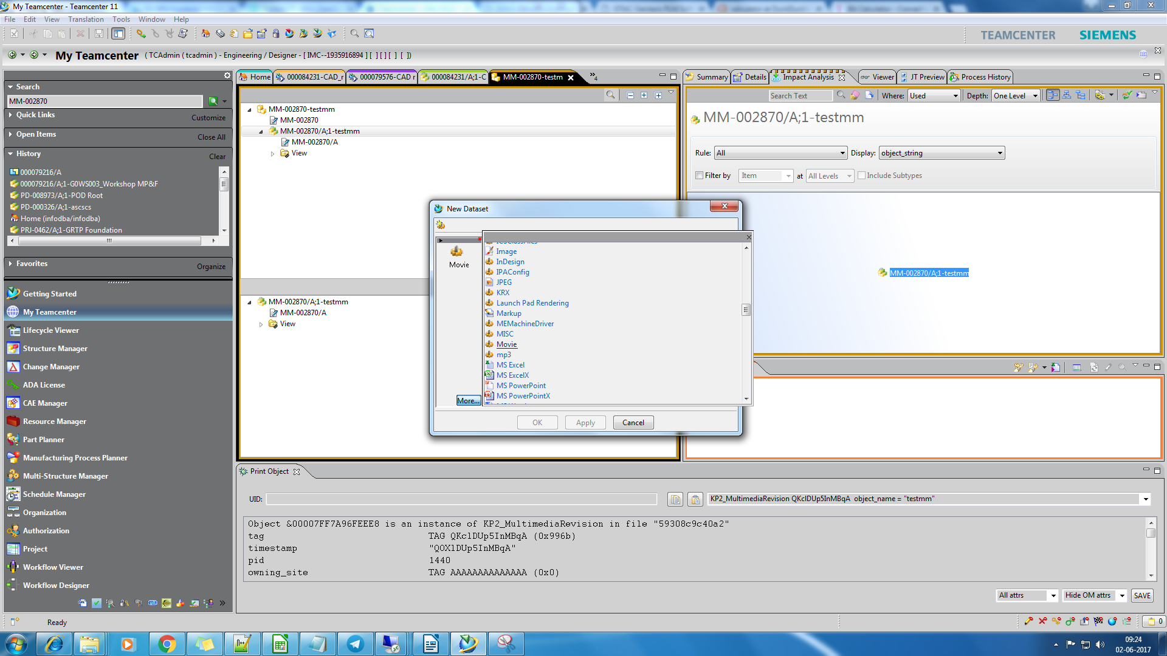
5) Click (...) import to upload files

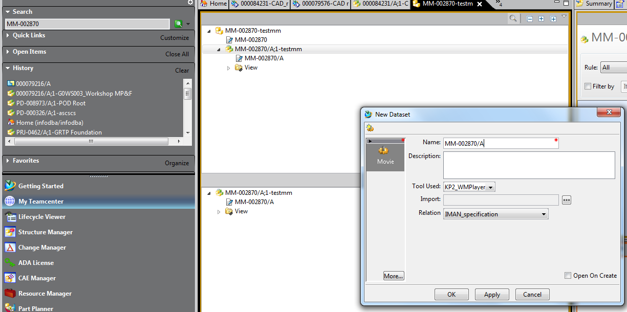

6) locate and select the file you want to upload, and click upload

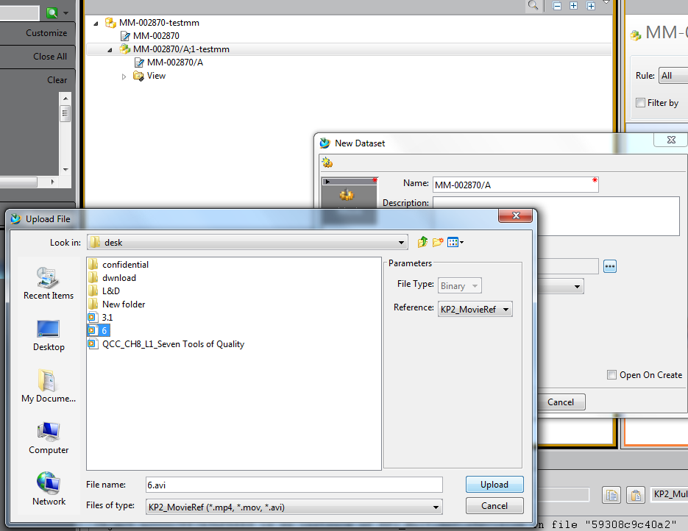

Click Ok

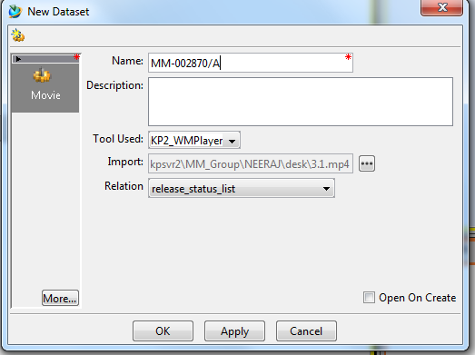

7) Select the created dataset and press contrl C(copy) -> contrl X(cut)
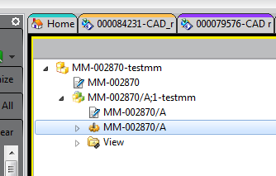

8) Now Select Item revision.and the (paste )cntl -> V

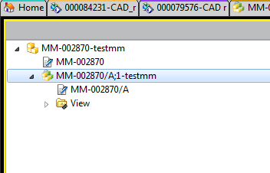

9) Go to Teamcenter AWC

refresh the browser for the item which you want to upload file.

